Minutes - Shelter Reference Group
Date: Wednesday, 20 March, 2013
Venue: Arup Offices, Kent Street, Sydney
Participants:  - Esther Charlesworth – AWF/HARB  - Bruce Hutchison – Partner Housing (PHAB)  - Kirsten McDonald – Arup  - Amir – World Vision International (WVA)  - Miia Barrow – Habitat for Humanity Australia (HFHA) | - James Schell – Habitat for Humanity Australia (HFHA)  - Sophie Cooke – Habitat for Humanity Australia (HFHA)  - Ifte Ahmed – AWF/HARB  - Supriya Mehta – Australian Red Cross (ARC)
Apologies:  - Richard Forsythe – Caritas Australia  - ChildFund – Sanwar Ali | - Brett Moore – World Vision International
Agenda:
- Introduction and overview of meeting
- Overview of agenda

- Sharing program lessons & Innovations:
- Urban Resiliency & Slum Upgrading. Dhaka, Bangladesh (AWF)

- SRG Priority activities - 2013
- Discuss/present work plan & any progress to date on agreed list of activities, including:
  - Shelter & DRR scoping study dissemination plan
  - AusAID: establishing key contacts & commencing dialogue with AusAID
  - ACFID Working Group: Becoming an ACFID Working Group
  - Shelter Forum
  - Online shelter forum/presence
  - Addressing regulatory barriers to post disaster shelter programming

- Others
  - World Habitat Day Event: Martin Place
  - IFRC – PASSA Training

- AOB

- Wrap up and Close
SUMMARY OF MEETING ACTION POINTS |  | WHO | WHEN
2. Sharing Program Lessons & Innovations:  - AWF/Arup trip report and project brief about Innovations Pilot work in Bangladesh to be shared via email with the group  - Draft a lessons learnt/sharing template to be used by agencies when sharing/presenting information (slideshow/word) |  | AWF/Arup  HFHA to draft | Before next meeting  April 15th
SRG Priority activities - 2013  - 3.1 Shelter & DRR – Extract toolkit from the report prepared on shelter & DRR to be shared with the group as a tool that can be used in the field  - 3.4 Shelter Forum  - Review notes on previous discussions about objectives of Shelter Forum to confirm if we agreed on formulating a public statement  - A program concept will be developed by HFHA & AWF and shared with the group in next couple of weeks  - Other orgs interested in working on the sub-committee to prepare for the forum should contact James and Esther  - Share guidelines DAR funding parameters (ie not advocacy)  - 3.7 World Habitat Day Event – HFHA will share ToR. Other orgs interested in getting involved should get in touch  - 3.8 PASSA Training – World Vision to send relevant contacts from Pacific who may be interested in attending training to HFHA |  | AWF  HFHA  AWF  HFHA  AWF  All  HFHA  HFHA  WV | Before next meeting  April 5th  April 15th  April 5th  Next meeting  ASAP

- Introduction and overview of meeting
- Overview of agenda was conducted.
- Sharing program lessons & Innovations:
- Ifte (AWF) gave an overview of the work that has been done today on the Innovations project: Urban Resiliency & Slum Upgrading. Dhaka, Bangladesh which is being conducted by AWF, ARUP and HFHA.
- Main activities to date have been a ToT on conducting vulnerability assessments for CSOs in October last year, and identification of main vulnerabilities by the community. Ifte is returning to Bangladesh in April to work with the community to finalise community mapping processes and develop a community action plan, identifying activities focused on draining, water, sanitation, shelter and others.
- A pilot set of activities is soon to commence (primarily focused on water, sanitation and drainage).
- The training methodology was adapted from work that Arup had done with the IFRC, as well as a review of other frameworks.
- Lessons learned after the training last year, will be used to further refine the training modules. These can then be rolled out in other project areas.
- HFHA plans to continue working with the community after this pilot phase to implement more of the activities identified during the pilot phase.
- This project is somewhat unique for doing both community mapping and cartographic mapping – most projects don’t merge these 2 approaches.
ACTION: AWF/Arup trip report and project brief about Innovations Pilot work in Bangladesh to be shared via email with the group.

- SRG Priority activities – 2013

3.1 Shelter and DRR Scoping Study
- The report has now been finalised, and all SRG members are encouraged to use the toolkit for evaluation of Shelter and DRR programs.
- Habitat will aim to use in 1-2 projects over the coming year and will share how it goes. Other agencies are encouraged to do the same.
ACTION: Work needs to be done to extract the toolkit from the report, and develop into a training module for partners.

3.2 AusAID: establishing key contacts & commencing dialogue with AusAID
- AusAID have undertaken a restructure, resulting in a new branch, titled – Health, infrastructure, water and resettlement branch. This branch is the likely focal point for SRG engagement & communication with AusAID.
- Initial contact has been made with AusAID but still waiting for a response.

3.3 ACFID Working Group: Becoming an ACFID Working Group
- Contact has been made and a response is expected later this week.
- Non ACFID member entities will need to be classified as observers or technical advisers.
3.4 Shelter Forum
- Friday June 21st was proposed date for forum, prior to AWF training being held on the 22-23rd
- Main objectives of the forum – sharing what we are doing with each other; widening the net to other agencies, students etc; raising the profile of the sector.
- There was some discussion about whether we should release a statement/invite media. Some concerns over inviting a journalist, especially if orgs are sharing lessons learned (failures and successes). Could look at a media release instead possibly?
- Also need to be careful as this is funded from AusAID Development Awareness Raising (DAR) fund. We cannot use this funding for advocacy, only for awareness raising & sharing of knowledge/lessons.
- Agencies are encouraged to think about relevant contacts they can invite; we can also use ACFID potentially as an avenue to publicise more widely.
- Case studies/presentations: which should develop an initial format. Agencies can submit 1 page concept notes, and best ones will be given opportunity to present at the forum.
ACTIONS:
- Review notes on previous discussions about objectives of Shelter Forum to look at whether we agreed on making a public statement.
- Share guidelines on what DAR pot of money can used for (ie not advocacy).
- A program concept will be developed by HFHA & AWF and shared with the group in next couple of weeks.
- Other orgs interested in working on the sub-committee to prepare for the forum should contact James and Esther.
3.5 Online shelter forum/presence
- HFHA shared a draft concept note on some ideas for an online knowledge hub. Details attached below.
- SRG Members to contact HFHA if they are interested in being involved in developing the site, or have any ideas.
3.6 Addressing regulatory barriers to post disaster shelter programming
- ARC is currently working on this and will send around documents soon.
3.7 World Habitat Day Event: Martin Place
- Event is planned for October in Martin Place. Concept is to build a small, example ‘urban slum’ in Martin Place. Will need the support of Uni/TAFE students, other agencies.
- HFHA will share the ToR, and other interested agencies can get in touch.
3.8 IFRC – PASSA Training
- PASSA (Participatory Approach to Safe Shelter Awareness) training is being conducted in Nepal from May 13-21. This is an approach to shelter developed by IFRC, and training is being supported by HFHA and IFRC.
- There are currently no participants coming from the pacific. WV will share contact details of the pacific shelter cluster, as there may be 1-2 spots left in the training for participants from the pacific.
- NSET a local NGO working in Nepal was mentioned as a potential technical partner for work in Nepal

- AOB –
N/A

- Next meeting & close
- HFHA will email around proposed date for next meeting
ATTACHMENTS:
3.1
SRG Report Dissemination Strategy

- SRG member agencies can disseminate to their overseas counterparts and partner agencies, particularly those agencies directly involved in the study (Caritas, HFH, Emergency Architects and Partner Housing).
- Where necessary, individual agencies may consider translating the shorter executive version of the report.
- SRG agencies should include a downloadable version on their websites. Consider if the executive version would be more suitable for easier accessibility.
- Should be disseminated at the SRG Shelter Forum in June 2013.
- SRG to approach AusAID and ACFID for dissemination through their channels.
- Downloadable report (or executive version) will be included on the HARB and AWF websites.
- HARB/AWF members will disseminate papers extracted from the report in international conferences and journals (e.g. i-Rec 2013 International Conference on Disaster Recovery & Resilience, Switzerland; Open House International Special Issue on Post-Disaster Reconstruction).
- HARB/AWF will disseminate through their academic programs and training courses (e.g. International Masters in Disaster Management, Resilience and Reconstruction; Pathways to Working in the Humanitarian Sector).

2. HFH/AusAID Innovations Fund Project Update

- AusAID Innovations Fund project on “Building Resilience in Urban Slum Settlements in Dhaka, Bangladesh”, July 2012 – June 2013.
- Partnership between Habitat for Humanity Australia (HFHA) (lead), Habitat for Humanity International Bangladesh (HFHIB) with technical support from Architects Without Frontiers (AWF) and Arup.
- Target community: Bihari community in Talap Camp, Mirpur, Dhaka (explain Bihari).
- Key activities to date:
- Background paper “Factors Pertaining to Building Resilience in Urban Slum Settlements in Dhaka” (AWF, 2012).
- Needs assessment survey (Arup, 2012).
- Training package (AWF and Arup, 2012).
- Training delivery (AWF: Community Based Participatory Risk Assessment; Community Based Action Planning. Arup: Resilience framework. 2012).
- Community Vulnerability Assessment following AWF toolkit (2012-13).
- Key planned activities:
- Cartographic and Community Maps (2013).
- Community Based Action Planning (AWF, 2013).
- Community Development Plan and pilot interventions based on the CBAP, possibly focusing on drainage, flooding/waterlogging prevention, solid waste management, WASH and housing improvements (2013).
- Inter-agency forum, Dhaka (July 2013).

3.4
Shelter Reference Group - Australian Shelter Forum – 2013

THEME: Suggested overall forum topic/theme (options to include…):

- ‘The importance of shelter’
  - Comments: This is important that we cover this off as the first session in the first forum. However, maybe just cover off this in one session to allow the forum to engage in meatier toopics…
- ‘Shelter/urbanisation/slum settlements/climate change dynamic’
  - Comments: I like this angle as they are all so interconnected… but we may be biting off more than we can chew with all this in one day??...)
  - There are many forums/conferences

POTENTIAL STRUCTURE: 1 day

- Keynote speaker(??): Graeme Saunders… + Q&A

- Case studies: (2/3 case studies??)
Focusing on Innovative proactive… Urban Slum work… Q&A and panel discussion??...

- Shelter & DRR scoping study – print that and Ifte/Esther can present Q&A

- Potential other topics:
  - Housing, Land & Property Rights
  - Technical Session – builder/architect/engineer
  - Participatory Approach to Safe Shelter Awareness (IFRC modle)

To consider:
Need facilitators??
Streams in the afternoon? Sufficient numbers for this?

Potential attendees
- Shelter based NGOs
- Students
- AusAID & ACFID
- Technical experts & entities

Venue: Sydney… details??

Number of people:???
Potential costs:??
Venue hire
Travel support costs for speakers etc
Equipment?
Printing from study
Prep & organisational support.

3.6

Concept Note for SRG Online Knowledge Hub
Objectives:
Online community of practice and knowledge hub to:
- Share lessons learned and experiences, especially related to innovative practice
- Share resources – link to other blogs and documents
- To create an online presence for the SRG raising its profile for advocacy and engaging other stakeholders
Possible Content:
The site can piggy back onto the UK Shelter Forum Word Press site: www.shelterforum.info

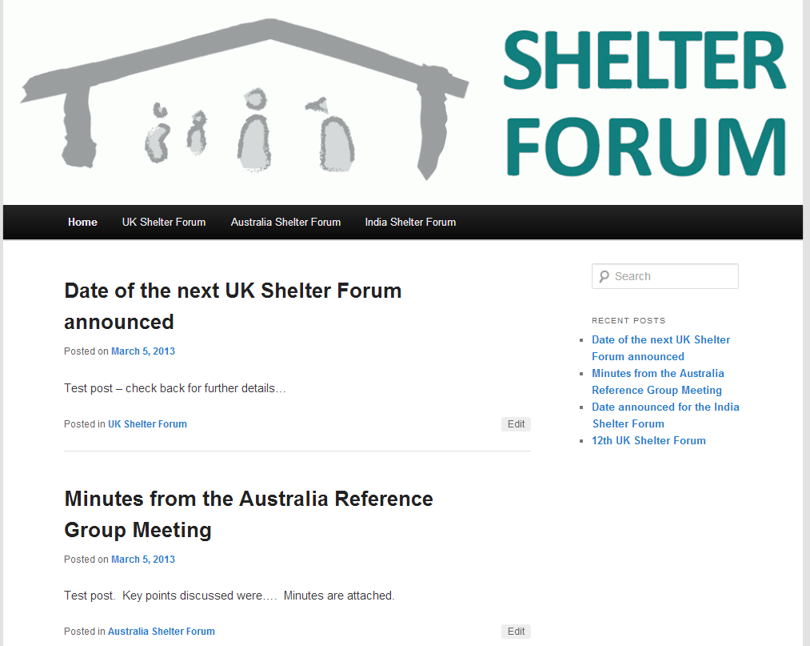
Main page content could include:
- Posts about meetings held with link to meeting minutes and presentations
- Dates for next meetings
- Abstracts of relevant reports/resources with links to full resources
- News items
Right hand column:
- Link to previous posts
- Links to other relevant sites/blogs and resources – including other CoPs (some egs listed below)
- Calendar with key events (?)

Examples of other sites:
www.interaction.org/work/shelter Possible layout – overview of the group, links to key events and documents in right column; news items/updates below
www.sheltercentre.org Possibility for hosting discussions– possibly more sophisticated than we can manage at this stage
www.sanitationmarketing.com Sanitation Marketing Community of Practice set up by the WASH Reference Group with funding from AusAID Innovations Fund – something to aim for in the future?! Including - Hosting webinars, ask an expert, information about upcoming training
www.seachangecop.org

Points to consider:
- One overall administrator to set up the page structure/design?
- The current shelterforum website is very basic, but we can add more plugins for increased functionality – the scope of this is mainly limited by how much time is able to be spent developing the site. There could be a dedicated volunteer or intern working on this?
- How many orgs should have admin rights to upload content? All going through single person/org, or several people able to update info

