Background Paper
Factors Pertaining to Building Resilience in
Urban Slum Settlements of Dhaka, Bangladesh

July 2012

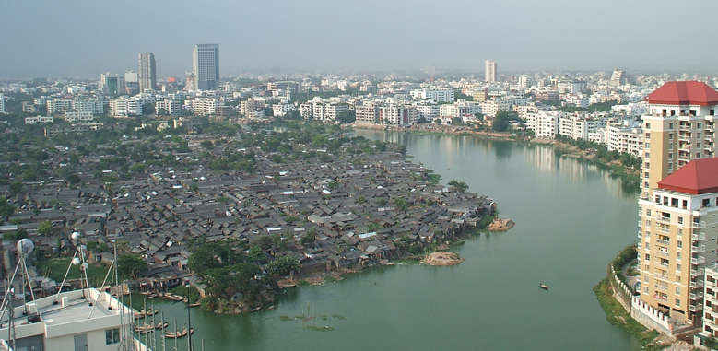

Dr Esther Charlesworth
Dr Iftekhar Ahmed
Architects Without Frontiers (AWF)
Melbourne, VIC



Executive Summary
- This paper has been written to provide the background for an AusAID-funded project Building Resilience of Urban Slum Settlements: A Multi-Sectoral Approach to Capacity Building being implemented by Habitat for Humanity Australia in Dhaka, Bangladesh.
- Dhaka, Bangladesh’s capital, is a rapidly urbanising megacity in one of the world’s most densely populated and poorest countries. Almost 30% of its more than 14 million population lives in slum settlements.
- Slum settlements are characterised by tenure insecurity and evictions, and controlled by mastaans – ganglords who charge exorbitant rents and charges for basic services. Such a situation deters investments for improving living conditions by slum residents and agencies.
- Poor quality and densely built housing is typical in Dhaka’s slum settlements and basic public infrastructure for water, energy, sanitation and hygiene are non-existent or very limited.
- A combination of human and natural factors results in various urban hazards with serious impacts on the urban poor. Here some of the key urban hazards in Dhaka are discussed.
- Flooding and water-logging, due to poor drainage, are widespread; windstorms cause havoc in slum settlements because of the weak construction of houses; unplanned urbanisation and sub-standard building practices pose great risk in the event of a major earthquake; urban fires are common and are often believed to be ignited intentionally; Bangladesh is one of the countries most threatened by climate change and impacts such as erratic weather, increased flooding and temperature rise are already evident.
- Bangladesh has a large number of development agencies, but most do not engage extensively in urban areas. Here some of the key initiatives are discussed.
- The Urban Partnerships for Poverty Reduction (UPPR) program is unique and is a very large program in urban slum settlements targeted for 3 million people in 30 cities including Dhaka; WaterAid Bangladesh addresses water, sanitation and hygiene (WaSH) in urban slum settlements with a range of partners; the Coalition for the Urban Poor (CUP) is a network of more than 40 NGOs and advocates for the rights of slumdwellers, and supports community-based organisations in slum settlements.
- The challenges of building resilience in urban slums are many, but there are also opportunities. Particularly recent government policies on urban development and climate change, as well as emerging interest among agencies to address urban issues, offer potential for advocacy for building resilience in urban slum settlements,.
1. Introduction
This paper has been written to provide the background for the project Building Resilience of Urban Slum Settlements: A Multi-Sectoral Approach to Capacity Building being implemented by Habitat for Humanity Australia (HFHA) in partnership with Habitat for Humanity International Bangladesh (HFHIB). Technical partners include Arup and Architects Without Frontiers (AWF) and the project is funded by AusAID under its NGO Cooperation Program Innovation Fund. The project is interested in building resilience of urban slum communities in Dhaka, Bangladesh with a specific focus on the built environment and will target communities in Mirpur in northwestern Dhaka.

2. Urbanisation in Dhaka and Implications for the Poor
Dhaka is the capital city of Bangladesh, which is the 7th most populous country in the world with a population of more than 150 million people inhabiting an area of 147,570 square kilometres (BBS 2011; UNFPA 2011), that is, an average population density of more than 1,000 persons per square kilometre – among the highest in the world. It is also one of the world’s poorest nations with nearly one-third of its population living in extreme poverty (BBS 2010; UNDP 2011; UNFPA 2011) and almost half the population below the national poverty line, the highest among all the South Asian countries (Mahbub ul Haq Human Development Centre 2011). While still predominantly rural with 28% of its population living in urban areas, Bangladesh is urbanising rapidly and is expected to have more than 50% urban population by 2050 (UN 2012).
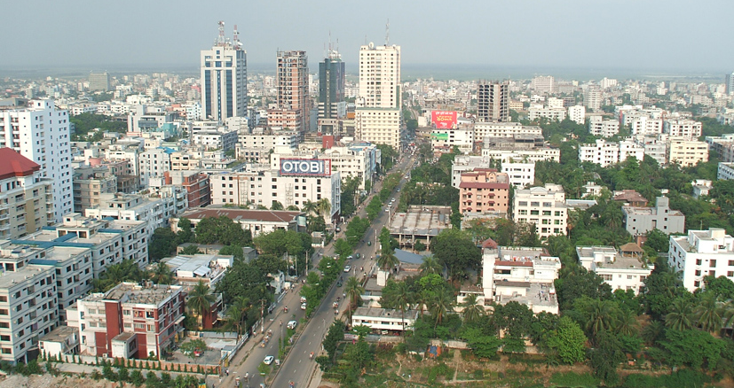
Fig. 1: Dhaka is one of the fastest growing megacities of the world.

The great bulk of the urban population is concentrated in Dhaka, comprising more than one-third the urban population of the whole country (World Bank 2012). Dhaka is among the fastest growing megacities in the world with a population of nearly 14 million (World Bank 2012) and projected to become the sixth largest megacity in the Asia-Pacific region by 2020 with a population approaching 20 million (UN-Habitat 2010) (see Figs. 1 and 2). It is estimated that density exceeds 18,000 persons per square kilometre within Dhaka’s municipal boundary (SDNP 2005), among the highest in the world. 300,000-400,000 mostly poor rural migrants arrive in cities annually (WSUP 2007) due to various ‘push’ factors including frequent natural disasters, increasing pressure on land, rural unemployment and underemployment and rural-urban income disparity, as well as ‘pull’ factors such as employment opportunities and better living standards in the city (UN-Habitat 2008; World Bank 2007). The bulk of urban growth, however, is from natural increase of the already large existing population and conversion of agricultural land and wetlands in rural areas on the fringes (Shafi and Payne 2007; UN-Habitat 2009).

Fig. 2: Urbanisation and population growth in Dhaka (source: Stimson Center 2009).

In absolute terms the average income in Dhaka is higher than the rest of the country, a reason that attracts migrants, but the cost of living is also higher. Inequality is higher in Dhaka than anywhere else in the country, and well over 90% of Dhaka’s urban poor lack secure tenure (DIG 2008). Therefore, despite having better economic opportunities, the poor in Dhaka tend to face greater exclusion and marginalisation. In Bangladesh there has been significant economic growth, indicated by a GDP growth of 53% from the mid-1990s to the mid-2000s (Deb et al 2008). However at the same time income inequality in urban areas had increased by 10% (Mahbub ul Haq Human Development Centre 2008); for the bottom 20% of the urban population, their share of income had slipped by 0.3% (Deb et al 2008). As observed, “the full potential of the poverty reducing effects of the accelerated growth of the period was not translated into reality” (Mahbub ul Haq Human Development Centre 2008). Other than income, inequality is reflected in other aspects – for example, one-third of Dhaka’s population occupy less than 1% of the total land area and the rest is distributed among wealthy groups (Afsar 2000). Quantitative measurement aside, income inequality in Dhaka is glaringly evident to the eye (see Fig. 3) – while new up-market shopping malls, restaurants and apartments continue to spring up in the city, the increasing number of people who are homeless and live on the streets or in slum settlements is also highly visible.
According to an earlier estimate (Islam 2005), in Dhaka about 35% of the people lived below the poverty line, out of which about 20% were classified as “hardcore poor” who lived in more than 4,000 slums or other informal settlements (BURT 2005). Recent estimates indicate that about 4 million people, that is, nearly 30% of the city’s population continues to live in such conditions (UN-Habitat 2010).
Rapid urban growth and consequent densification are exerting unprecedented pressure on Dhaka’s infrastructure and public services, and is negatively affecting habitability for the entire urban population. For the urban poor the consequences are severe. Highly restricted availability of land, increased commuting time and costs, reduced access and increased cost of basic services, insecurity from crime and violence, competition for resources and employment, degraded environment and increased vulnerability to disasters and climate change impacts are some of the key outcomes of urbanisation that confront the urban poor and adversely affect their opportunities for building resilience.

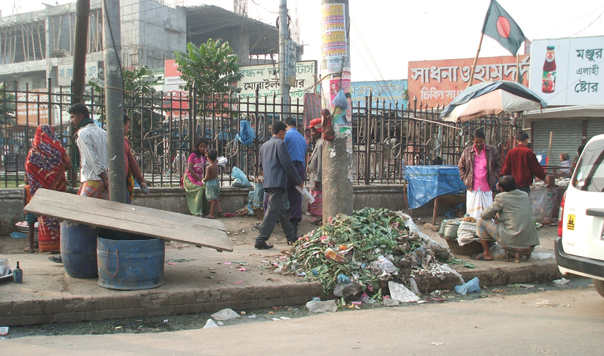
Fig. 3: Poverty is glaringly evident in the streets of Dhaka.

3. Characteristics of Urban Poor Settlements in Dhaka
More than 4 million people in Dhaka live in slums and squatter settlements without secure tenure and under constant threat of eviction. Additionally several hundred thousand are homeless, or ‘floating’ - dwelling on the streets, footpaths, railway and bus stations, under bridges, etc. Dhaka has a total of 4,300 slums, which by some are euphemistically called “informal settlements” (BURT 2005b). 93% of Dhaka’s ‘informal settlements’ are squatter settlements, 27% on government owned land and 66% on private land. Almost 80% of the households in these settlements pay rent (CUS et al 2006).
A unique feature of these slums is that, given the minimal efforts by the government to provide even the most basic infrastructure and services, let alone to enforce policies to protect basic rights of residents, these settlements are managed by local ‘mafia’ known as mastaans. These gang leaders and their thugs act as informal landlords – collecting rents and exorbitant fees for basic services. Even though the land belongs to government agencies or private owners, the actual owners usually receive very little if any of this substantial ‘informal revenue’ since the mastaans rely on political patronage and camaraderie with police, often through bribes, to protect their ‘business’ of exacting ‘rents’ and ‘fees’ for basic services and pocketing the proceeds. This informal structure of extortion and crime is widespread and maintains the status quo in Dhaka’s slums. The mastaans also maintain close relationships with political and party leaders and manage their efforts to extort votes from the urban poor during elections.
With few exceptions government interventions in Dhaka’s slums have focused on forced evictions to clear government or private land for ‘development’ purposes, offering little if any recourse to the urban poor who are evicted in the process. For example, recently in April 2012, a major slum eviction was carried out in Korail, one of the largest slum settlements in Dhaka, where more than 2,000 houses were demolished by force (Subramanian and May 2012). This highly politicised and conflict‐laden manipulation of Dhaka’s slum population, combined with the overall absence of secure tenure, not only deters the potential significant investments of the slum dwellers themselves to improve their housing and living conditions, but also limits donor and NGO investments in slum upgrading, since such investments run a great risk of being destroyed during government-led slum ‘clearance’ drives. The net result is that Dhaka’s urban poor live under constant threat of eviction and are largely left to fend for themselves in an environment of crime, violence and anarchy controlled by mastaans.
As a result almost all housing in Dhaka’s informal settlements consist of poor quality structures (temporary, flimsy or dilapidated) and are densely crowded with more than 95% of the houses (one room dwellings) less than 14 square meters. Overcrowding is also evident from the high population density of more than 250,000 persons per square kilometre in some Dhaka’s slum settlements (CUS et al 2006).
Even the most basic public infrastructure is often non-existent (see Fig. 4). Most of these settlements lack clean water, adequate sanitation and drainage and are subject to frequent flooding and water-logging. These factors, combined with high densities and inadequate healthcare, create serious health risks for slum dwellers, often impacting on their earning ability, as well as posing health risks for the wider urban community. Moreover as is noted above, given the widespread tenure insecurity, there is little incentive to invest in housing or infrastructure improvements. In some cases even in the few areas where poor households have legal landownership, since their rights are seldom protected and since they are increasingly under market pressure from real estate developers, they fear eviction or loss of property because of complications in land administration and hence do not feel motivated to invest in housing improvements (Shafi and Payne 2007).
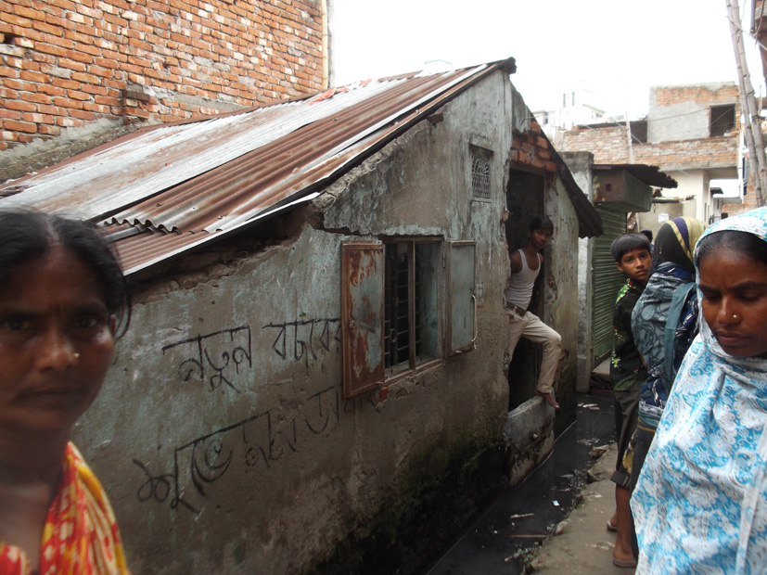
Fig. 4: Poor housing and lack of basic infrastructure is characteristic of Dhaka slums.

Water, sanitation and hygiene are key issues in informal settlements. The main provider of water supply and sewerage in Dhaka is the governmental Dhaka Water Supply and Sanitation Authority (DWASA), but it does not supply water directly to slum settlements because of illegal tenure. Nonetheless the dwellers of these settlements often rely on DWASA’s piped water supply from usually remote public standpipes (DWASA 2006), where mainly women queue from very early in the morning to collect water for household use. There are also some private tubewells (Rahman 2004), which charge high rates to slum residents. A large proportion of the urban poor population obtain water supply from illegal connections to DWASA supply, often controlled by mastaans who charge extortionate amounts of money from the poor (WSUP 2007). Electricity connections in most slum settlements similarly consist of illegal pirate hook-ups from the main grid of the governmental Dhaka Electric Supply Authority (DESA), controlled by mastaans. Most of the urban poor tend to use unhygienic latrines or shared sanitary latrines (DWASA 2006; WSUP 2007), resulting in a public health hazard. Dhaka City Corporation (DCC) is responsible for surface drainage, non-sewered sanitation and solid waste disposal throughout the city, but its role in slum settlements has been minimal. It is common to find garbage heaps on the periphery of slum settlements, ignored by DCC, and posing a health hazard to the slum communities.

4. Urban Hazards and Impacts on Slum Settlements in Dhaka
Bangladesh is a riverine country consisting of low-lying floodplains and annual monsoonal floods is endemic. Other significant natural hazards include cyclones and earthquakes. In cities such as Dhaka, rapid and unplanned urban growth, densification and a range of human factors combine to create specific conditions of vulnerability where it is difficult to disaggregate natural and human-induced hazards. Such hazards have compounded impacts on the urban poor because of their poverty and marginal living circumstances. Factors such as poor waste management and inadequate public health and sanitation amplify the effects of other hazards and trigger a set of cascading secondary impacts. It is beyond the scope of this paper to discuss the wide range of hazards affecting slum communities, but some of the key urban hazards in Dhaka are discussed below.
4.1 Floods and Water-Logging
Various human interventions and unplanned urban development have created conditions that result in flooding and water-logging in Dhaka. Due to the high population density and consequent demand for land, canals and ponds, and more recently wetlands on the eastern and north-eastern sides of the city, continue to be filled to make space for buildings and roads. This has not been accompanied by an adequate drainage plan and hence heavy rainfall easily leads to flooding and water-logging. The Dhaka Metropolitan Development Plan (DMDP) 2005-15 had extensive provision for large water-retention ponds, but this has not been followed and most of the earmarked sites have been or are being built upon (see Fig. 5). In the last decade, in addition to regular and frequent smaller flooding events, Dhaka experienced severe floods in 2004, 2007 and 2009 (Bangladesh News 2009; Khan 2010). It is common to find water-logging in many densely built neighbourhoods just after a heavy rain shower.
The southern part of the city is bounded by the Buriganga River and the western part has a flood protection embankment (see Fig. 6), limiting options for urban expansion only to the north and east. The eastern part of Dhaka is densely populated, with the majority of settlements consisting of low-income or poor settlements (see Fig. 7). This area is the most severely affected by floods. Although there is a plan to build an embankment around this area (Khalequzzaman 2010) (see Fig. 6), experts are concerned that this may impede water flow and cause further water-logging (Islam 2005). Paradoxically, the most affluent neighbourhoods of Dhaka – Gulshan, Banani and Baridhara - are also located in this area, and are thus also subject to flooding (see Fig. 8). Although the project area, Mirpur, is on relatively high land and is protected by the western embankment, because of poor drainage water-logging is common there (see Fig. 9).
Fig. 5: Dhaka Metropolitan Development Plan (2005-15) showing large water-retention ponds (source: SENES Consultants and Techno Consult International 2007)
Fig. 5: Map of Dhaka showing the western embankment and the proposed eastern embankment (dotted green line). The dark coloured areas are below 10 metres and subject to flooding (source: Khalequzzaman 2010).

Fig. 7: Map of Dhaka showing the locations of slum settlements. Note the high prevalence of slums on the eastern side, the part of the city that is most affected by floods (source: CUS et al 2006).
Fig. 8: Flooding in the affluent Gulshan area in 2004.
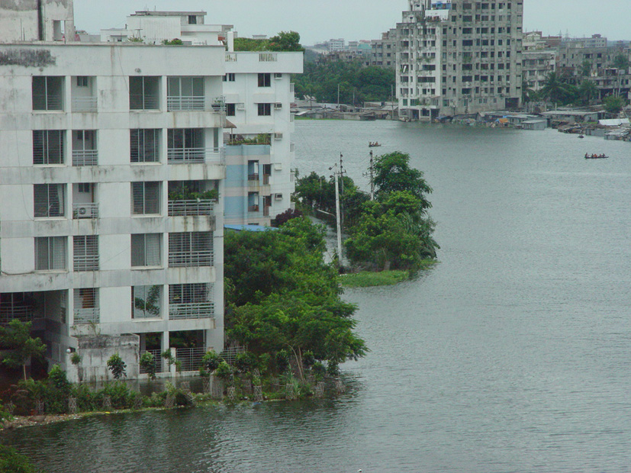
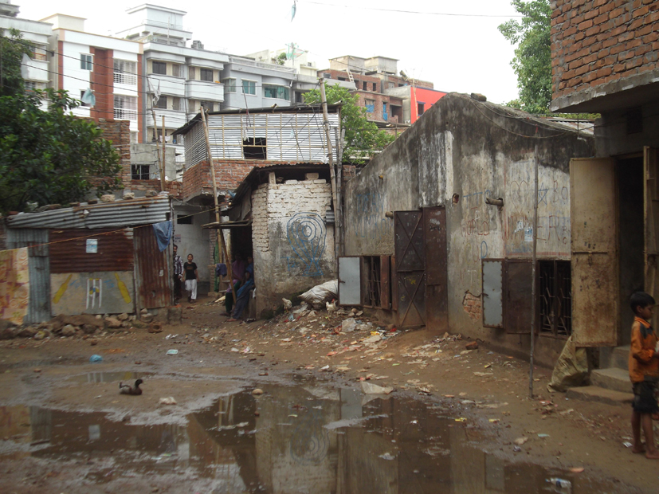
Fig. 9: Water-logging in a Mirpur slum after a brief rain shower.
Floods impact the urban poor in a number of ways. Their housing, usually built of flimsy or sub-standard materials, and household assets get damaged; water supply gets polluted or become unavailable; sanitation gets affected leading to spread of contagious diseases; and significantly, livelihoods get disrupted (Khan 2010). Most of the urban poor work in the informal sector and typical activities such as home-based income generation, hawking on the streets, driving rickshaws, travelling to factories for work, all get affected. In extreme floods, they have to abandon their settlements and seek shelter on high roadsides, schools or mosques. Floods and water-logging are possibly the most serious hazard impacting slum settlements in Dhaka.
4.2 Windstorms
Seasonal north-westerly windstorms are common in Bangladesh during March-May (Mannan 2009), some of which become tornadoes. For example, in 2000 a strong tornado in outlying areas to the north of Dhaka caused severe damage, human casualties and injury (Tornado Project 2000). There are also cases of recent windstorms in other times of the year which do not follow the typical seasonal pattern, possibly due to climate change (Finch and Dewan undated). Sometimes the windstorms are accompanied by severe hail with large hailstones (Mannan 2009), which can cause great damage and injury.
In urban slum settlements, even minor windstorms can cause havoc because of the typically weak construction of houses. The commonly used corrugated iron roofing sheets get blown off, wind-driven rain penetrates into the house and damages household assets, and the residents’ well-being is affected. There are no community-based early warning systems, nor recovery programs, and the urban poor in Dhaka have to face the adversity and manage their own recovery with great difficulty (see Fig. 10).
Fig. 10: A slum household affected by a thunderstorm (source: Mannan 2009)

4.3 Earthquakes
Dhaka is located in a moderate earthquake risk zone (see Fig. 11), but experts have been warning of severe consequences if a major earthquake does strike this densely built and populated city (Hindustan Times 2010; New Age 2011). Because of unplanned urbanisation and sub-standard building practices, one prominent earthquake expert has suggested that “Dhaka is among the most vulnerable megacities in the world” (J.R. Choudhury in the New Age 2011) and is among the 20 most vulnerable cities in the world (Ahmed and Ahmed 2010). Although no significant damage has yet been caused, strong tremors such as in 2010, and more recently in March 2012, have rocked the city and created panic among its residents (iaminweb 2010; USGS 2012; Vervaeck and Daniell 2012).
Fig. 11: Earthquake risk map of Bangladesh.

Fig. 12: Poorly constructed brick houses in slum settlements pose risk in earthquakes.
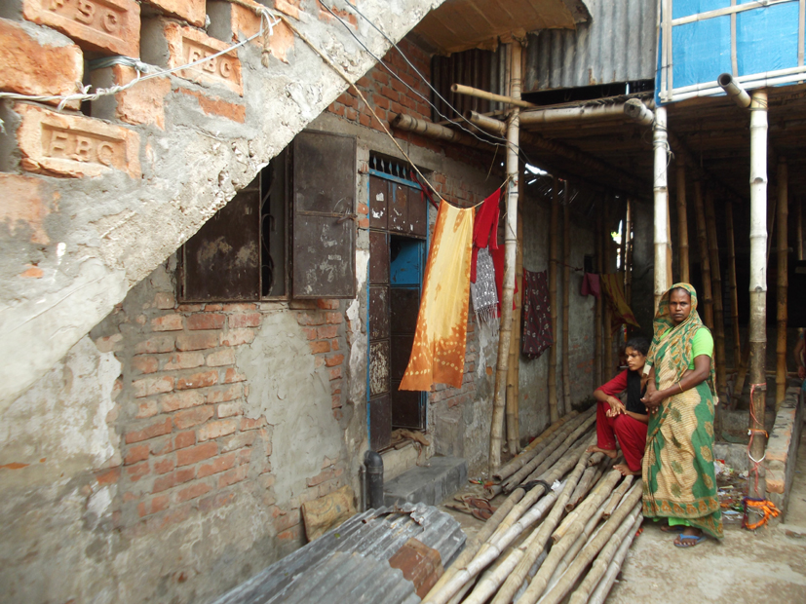
One of the main dangers presented by an earthquake is collapsing buildings killing or trapping people. This is more acute in the case of multi-storey buildings, particularly those built of heavy materials such as brick, stone and concrete. In many cases houses in slums are built of light-weight materials such as metal sheet, timber and bamboo, and are usually 1-2 storeys high. Thus the risk of getting killed or seriously injured in an earthquake is not very high. However, increasingly, brick is being used to build walls of houses in slums, which are often poorly constructed and lack a reinforcing structure (see Fig. 12). Additionally, old dilapidated buildings are occupied by squatters and become part of slum settlements. Such buildings are a source of risk to slum residents in the event a strong earthquake strikes. The densely built settlements with typically narrow roads amplify the risk because of the difficulty of carrying out rescue operations.
4.4 Urban Fires
Fires in Dhaka, particularly in slum settlements, are common. For example, recently in May 2012, a huge fire in slums of north-western Dhaka destroyed 150 houses and injured 12 people (Akter 2012; Daily Star 2012) (see Fig. 13). Because of the typically flammable building materials in slums (timber, bamboo, etc), fires ignite and spread easily, especially during the hot dry season (March-May). Various reports suggest that such fires are intentionally lit to evict slum residents, or are a result of feuds between maastan gangs (Ahmed undated; Ahmed 2010; Daily Star 2011).
As with other hazards, because of the high density of the slum settlements, firefighting, evacuation and rescue pose great difficulty and it is common for slum residents to lose household assets and belongings, an adversity that the poor are ill-prepared to deal with. Even if fire stations are nearby, given Dhaka’s incessant traffic congestions and narrow roads in slums, it proves almost impossible for fire wagons to reach the site on time (Ala 2010).
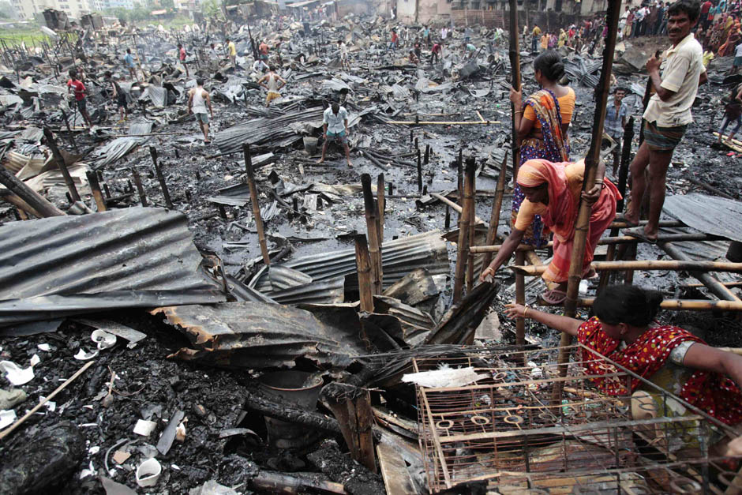
Fig. 13: A slum settlement razed to the ground in a fire in May 2012 (source: National Post 2012).

4.5 Climate Change Impacts
It is widely cited that Bangladesh is one of the countries in the world most threatened by climate change (see for example IRIN 2009; WWF 2009). Dhaka being a low-lying city surrounded by rivers and wetlands, and having a tropical monsoonal climate, has historically experienced natural floods. However, climate change has resulted in erratic weather patterns, and increased frequency and intensity of extreme weather events as evident globally with the greatest impacts in developing countries (Anderson and Bausch 2006; Rosenzweig et al 2011; Tompkins 2002), particularly on the poor (Satterthwaite et al 2007).
In 2009 an unprecedented cloudburst in Dhaka broke a 53-old rainfall record and killed six people, and Dhaka also experienced the highest temperature of 38.7ºC in 14 years (Bangladesh News 2009; Khan 2010). With its low elevation (2-13 metres), Dhaka is vulnerable to inundation by a small rise in sea level induced by climate change (UN-Habitat 2008). Dhaka continues to draw climate change refugees from rural areas, fuelling its population growth and adding to its existing widespread poverty (Ober 2010; Rabbani 2010). Despite the government’s various initiatives to address climate change, the urban poor are generally neglected (Banks et al 2011).
The impacts of floods and water-logging, and associated secondary effects on the urban poor who live in settlements in marginal areas and without drainage has been discussed above in section 4.1, and these impacts can be expected to magnify in the future (see Fig. 14). Another key impact of climate change in Dhaka is heat stress. A recent 10-year record indicates a consistent rise of average temperature (Rabbani 2010) (see Fig. 15). A study on the effects of climate change on the urban poor in Dhaka indicated serious health impacts, such as fever, and disruption of water services (Khan 2010). In addition, increasing urban development and traffic will continue to contribute to the ‘urban heat island effect’ by generating more heat and adding to the climate change induced temperature rise, once again with a range of implications for the urban poor including loss of productivity and income, negative impacts on health and disrupted water and energy supplies. Such a situation is conducive for the ignition and rapid spread of urban fires as discussed above in section 4.4.
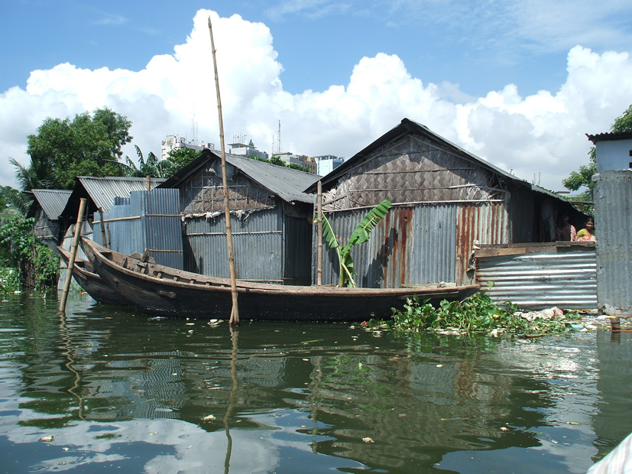
Fig. 14: Floods in Dhaka slums, already regular, can be expected to magnify in the future due to climate change.
Fig. 15: A 10-year record showing rise of temperature in Dhaka (source: Rabbani 2010).
5. Key Actors Addressing Urban Poor Issues
Bangladesh has a large number of bilateral/multilateral agencies, NGOs and other development organisations addressing poverty. However it appears that most of the efforts are targeted at rural areas and the urban poor tend to be disregarded (Banks et al 2011). Because of the tenure insecurity issue, and its highly politicised and volatile nature, particularly in Dhaka where there is tremendous pressure on land, most agencies are unable or unwilling to implement development programs in urban slum settlements. The work of agencies in this field in Dhaka is scanty and scattered, and therefore some of the key examples are discussed below. Also as this project focuses on the built environment in urban slums settlements in Dhaka, it has been chosen here to discuss initiatives that relate to this field.
5.1 Urban Partnerships for Poverty Reduction (UPPR) Program
UPPR is the largest initiative in Bangladesh targeted specifically at the urban poor. Its aim is to improve the living conditions and livelihoods of 3 million poor people in 30 cities including Dhaka during 2008-2015. The program is implemented and managed by the United Nations Development Programme (UNDP) and funded largely by the UK’s Department for International Development (UK-AID) and to some extent by UNDP, and receives in-kind technical and other support from the Government of Bangladesh’s Local Government Engineering Department (LGED). UPPR interacts with a range of non-governmental and governmental actors to deliver its program including municipalities and city corporations (such as DCC).
There are two main funding modalities: The settlement improvement fund (SIF) for providing water, sanitation and various physical and environmental improvements (latrines, drainage, footpaths, etc) and the socio economic fund (SEF) to build capacity for accessing employment and business opportunities, and to address social development issues. At the core of UPPR is the formation of primary groups in slum communities known as Community Development Committees (CDCs), which form CDC clusters and town level federations. At least 90% of CDC leaders are women. The CDCs are supported to plan, manage and implement the outputs of the SIFs and SEFs.
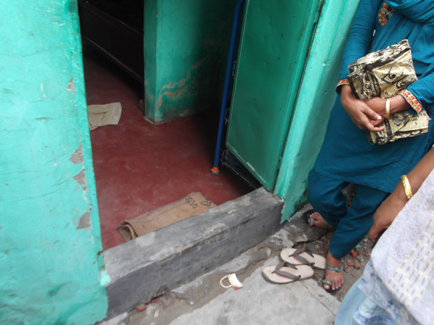
Fig. 16: Due to strong community demand UPPR has started flood-proofing floors of houses in slums

Although UPPR’s projects improve the built environment in urban slum settlements, its contribution to building physical resilience is inadvertent and does not stem from a specific analysis of urban hazards or other factors that directly undermine the resilience of slum communities. The program does not have any mechanism to improve housing, one of the key vulnerable elements in slums. Nonetheless, because of strong community demand, UPPR has begun to raise and strengthen the typical earthen floors of slum houses to resist floods and water-logging (see Fig. 16).
5.2 WaterAid Bangladesh (WAB)
Water, Sanitation and Hygiene (WaSH) is possibly the area where most agency activity is carried out in urban slum settlements of Bangladesh. Although there are a number of actors in this field, WAB is a key agency in this field as it has been operating for a long time since 1986, and supports and works in partnership with a range of agencies and initiatives such as the AusAID, Thames Water and SIDA (Swedish International Development Agency) funded ‘Services to the Urban Poor’ and the UNICEF-supported ‘WaSH Cluster’ (Rahman and Ellery 2011; WaterAid 2011). WAB is a key partner of the agency Water & Sanitation for the Urban Poor (WSUP); WSUP with funding from the World Bank is implementing water service improvements and sanitation for more than a planned 100,000 slum residents (WSUP 2007; WSUP 2012). It operates in three wards near Mirpur, the target area of this project and thus offers opportunity for synergy. An important partner of WAB is a local NGO called Dushtha Shaystha Kendra (DSK), which implements innovative community WaSH programs in urban informal settlements (DSK 2005; Rahman 2004).
A key aspect of the work of WAB and its partners involves negotiation with the Dhaka Water and Sewerage Authority (DWASA) and the Dhaka City Corporation (DCC), the main governmental service providers, to provide water supply and drainage to slum settlements through collateral guarantee. In most cases these are bulk connections at slum boundaries, not door-to-door connection inside slums. However within slums, community tube-wells (hand-pumps) and sanitary latrines are built (see Fig. 17), within an integrated program of community development focusing on health and hygiene; recent initiatives include rainwater harvesting, important in the context of extensive arsenic contamination of groundwater in Bangladesh (DSK 2010).
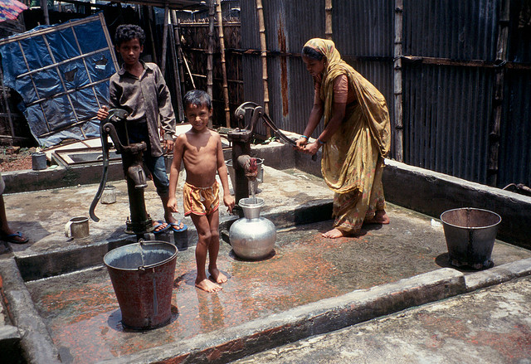
Fig. 17: A community water point in a Dhaka slum built by DSK (source: Flickr 2009).

5.3 Coalition for the Urban Poor (CUP) & Associated Community-Based Organisations
CUP is a network of more than forty NGOs supporting the urban poor and active in seven urban slum settlements. CUP advocates at the government level and with donors for promoting pro-poor policy, particularly to prevent slum evictions. In the past CUP assisted in institutionalizing voting rights of informal settlement dwellers, thus paving the way for formation of the community-based BOSCs (translated: Slumdwellers’ Rights Protection Committees) with more than 2 million members. BOSCs have facilitated demands on Dhaka’s Ward Commissioners and managed to get access to water supply, sanitation and electricity in some settlements (Banks 2008). BOSCs act as a non-confrontational alternative to public demonstrations by seeking communication channels with policymakers. CUP has also partnered with agencies such as UNICEF to build community latrines in urban slums (see Fig. 18). CUP represents a key facility for strengthening resilience of the urban poor.
Since 2007, BOSC has been re-named as NDBUS (translated: Urban Poor Slumdwellers Development Organisation) and funded by the Bill and Melinda Gates Foundation’s Urbis program (NDBUS 2010). It also derives support from UPPR and implements a wide range of community development programs in slum settlements. Despite these initiatives, several observers have noted that their impact on reducing urban poverty has been minimal (Banks 2008; NDBUS 2010).
Fig. 18: Community latrines in a Dhaka slum built by CUP with the support of UNICEF.
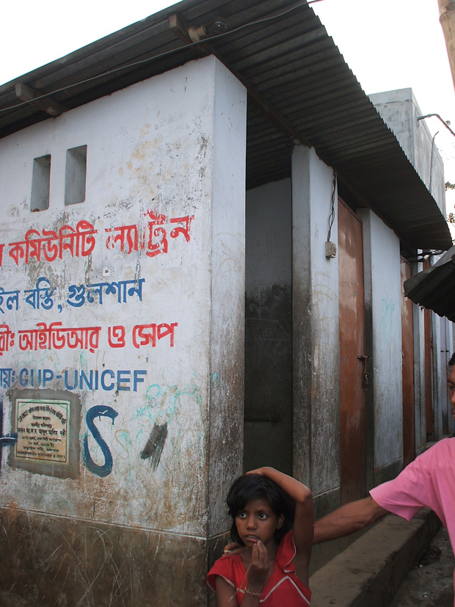

6. Challenges and Opportunities
The preceding sections have in various ways outlined the many challenges relating to slum settlements in Dhaka and therefore will not be elaborated further here. To provide a snapshot of the key challenges:
- Longstanding and ongoing bipartisan political bickering is a fundamental obstacle to development in Bangladesh. National elections being scheduled for 2013 might lead to unrest and political instability.
- There is a lack of real political commitment for pro‐poor policies.
- NGOs have assumed the role of government in many areas and thus diminished public sector commitment.
- Limited focus on urban poverty with few active agencies compared to rural areas.
- Most national NGOs and CBOs are by‐and‐large weak and have yet to realise their potential power in advocating for pro‐poor urban policies and programs.
- Rapid urban development and population growth creates a context of ever-changing circumstances and disallows the stability required to implement sustainable programs.
- Vast corruption in the government and in slum settlements via the mastaans control of rent collection, of water supply and electricity.
- Due to the lack of secure tenure and clear and enforced policies to protect the rights of slum dwellers, Dhaka’s urban poor live in constant threat of eviction.
- Limited engagement of disaster management agencies in urban areas; lack of climate change adaptation and resilience building policies that could benefit the urban poor.
Despite these serious challenges, there are potential opportunities for building resilience in slum settlements. However quick results and ease of wide replication should not be expected; realisation of these opportunities would require a long-term perspective and sustained advocacy to bring on board a wide range of actors:
- There have been very few attempts to improve housing and its resilience in urban slum settlements, although housing represents a key vulnerable aspect. There is opportunity for contributing in this field from lessons in other developing countries.
- The government is taking climate change seriously and has been ahead of many other developing countries in the formulation of national strategies. Although the urban poor have so far been ignored, there is opportunity for advocacy for building resilience using these strategy instruments.
- Similarly, the National Urban Sector Policy formulated in 2010 offers another policy instrument for advocating resilience building in urban slum settlements.
- Although the focus of the government’s Disaster Management Bureau (DMB) and most NGOs working in the disaster management field has been in rural areas, with recent earthquakes in Dhaka, there is more interest in addressing urban resilience. This might offer the opportunity to also address a wider range of urban hazards, particularly floods.
- Notwithstanding the limited engagement of the government and NGOs in urban slum settlements, the first Bangladesh Urban Forum was held in 2011, and was attended by a wide range of agencies (Carr 2012), indicating an emerging interest in addressing urban issues and thus potential future opportunity for strengthening resilience in urban slum settlements.

7. References
To be provided later.

Substantial development has taken place across the river on the south, but this is outside the metropolitan boundary.
For details of UPPR refer to www.undp.org.bd
National Adaptation Program of Action (NAPA 2005) and Bangladesh Climate Change Strategy and Action Plan (BCCSAP 2008).

